For Immediate Release PRESS RELEASE 29 AUGUST 2022

FORMER DIRECTOR-GENERAL OF EDUCATION YBHG. DATUK DR. HABIBAH
JOINS TEACH FOR MALAYSIA AS TRUSTEE
KUALA LUMPUR: Teach For Malaysia (TFM) is pleased to announce the appointment of YBhg. Datuk Dr. Habibah Binti Abdul Rahim to its Board of Trustees. YBhg. Datuk Dr. Habibah was the former Director-General of Education, having served the Ministry of Education (MOE) Malaysia for more than 34 years before her retirement in April 2021.

YBhg. Datuk Dr. Habibah began her career as a secondary school teacher in Selangor and Kedah. Her positions include the Head of the Delivery Management Office for the Education National Key Economic Area, Executive Director of the Education Performance and Delivery Unit (PADU), Director of the Educational Planning and Research Division, and Deputy Director General of Education (Policy and Curriculum).

YBhg. Datuk Dr. Habibah graduated with a Bachelor of Science with Honours in Biology from the University of Salford in 1984. She later earned the degree of Master in Education in 1993 at the University of Bristol, and Master of Art in Sociology in 1999, followed by a Doctorate in Education in 2001 from Stanford University.
YAM Tunku Ali Redhauddin ibni Tuanku Muhriz, Chairman of Teach For Malaysia said,
“We are pleased to welcome YBhg. Datuk Dr. Habibah to the Board. She brings invaluable insights with her extensive experience in education system transformation, policy development, as well as programme implementation and evaluation. Her experience will further strengthen our partnership with the Ministry of Education as we look to continue scaling our impact.

We are proud to have partnered with the Ministry of Education for over a decade. We believe that the recent recognition as the recipient of the 2022 Merdeka Award for Education and Community, is a testament to this partnership and our continuing aim to contribute to the nation’s development.”
YBhg. Datuk Dr. Habibah said,
“It is important to develop leaders at every level in education, particularly in helping our children navigate the effects of the pandemic. I am excited to be part of Teach For Malaysia. It is a growing movement with a vision of empowering students to be leaders of the future of this nation, working towards ensuring all children- no matter their background- receive quality education.”
Chan Soon Seng, CEO of Teach For Malaysia said,
“With 330 participants between our 10th cohort of TFM Fellows and 3rd cohort for Program Duta Guru participants, this is TFM’s biggest year to date. As we continue to scale our impact in the education ecosystem in line with our 2030 strategy, we are delighted to have YBhg. Datuk Dr. Habibah as a Trustee. I am confident that her expertise and leadership in education reform will guide us in our goal to continue to be a trusted partner in enabling the education ecosystem’s transformation.“

YBhg. Datuk Dr. Habibah joins the other current members of the Board of Trustees: Chairman and Founding Trustee - YAM Tunku Ali Redhauddin Ibni Tuanku Muhriz; Founding Trustee - Shahnaz Al-Sadat Abdul Mohsein, Trustees - Chen Li-Kai; Datuk Yvonne Chia; and Dato’ Tharuma Rajah.

Appendix

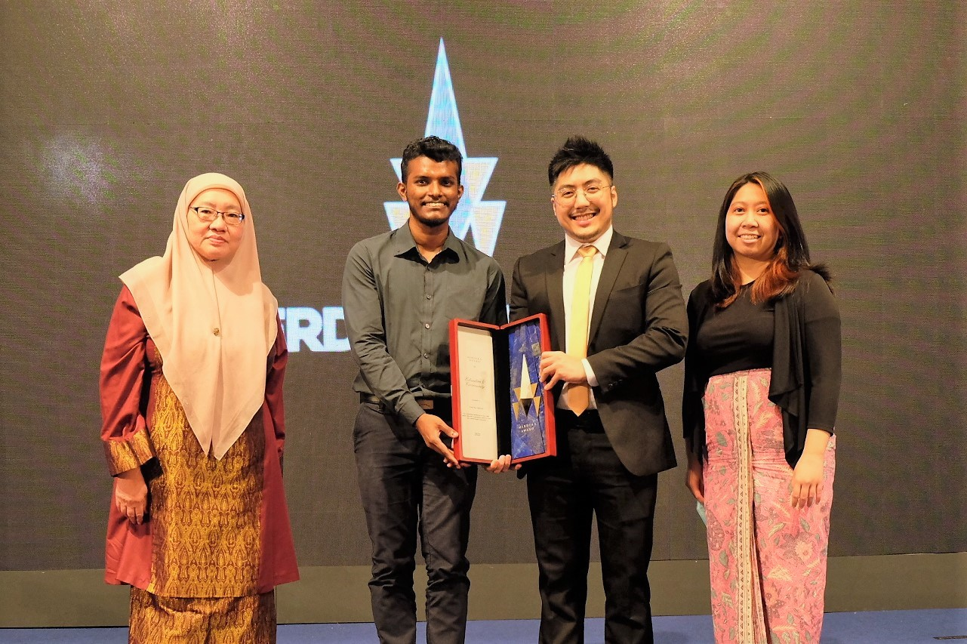

Merdeka Awards 2022 Ceremony. From left: YBhg. Datuk Dr. Habibah, Shashi Varmaan (TFM student), Chan Soon Seng (TFM CEO) and Venessa Sambai Anak Usei (Alumni Board President)

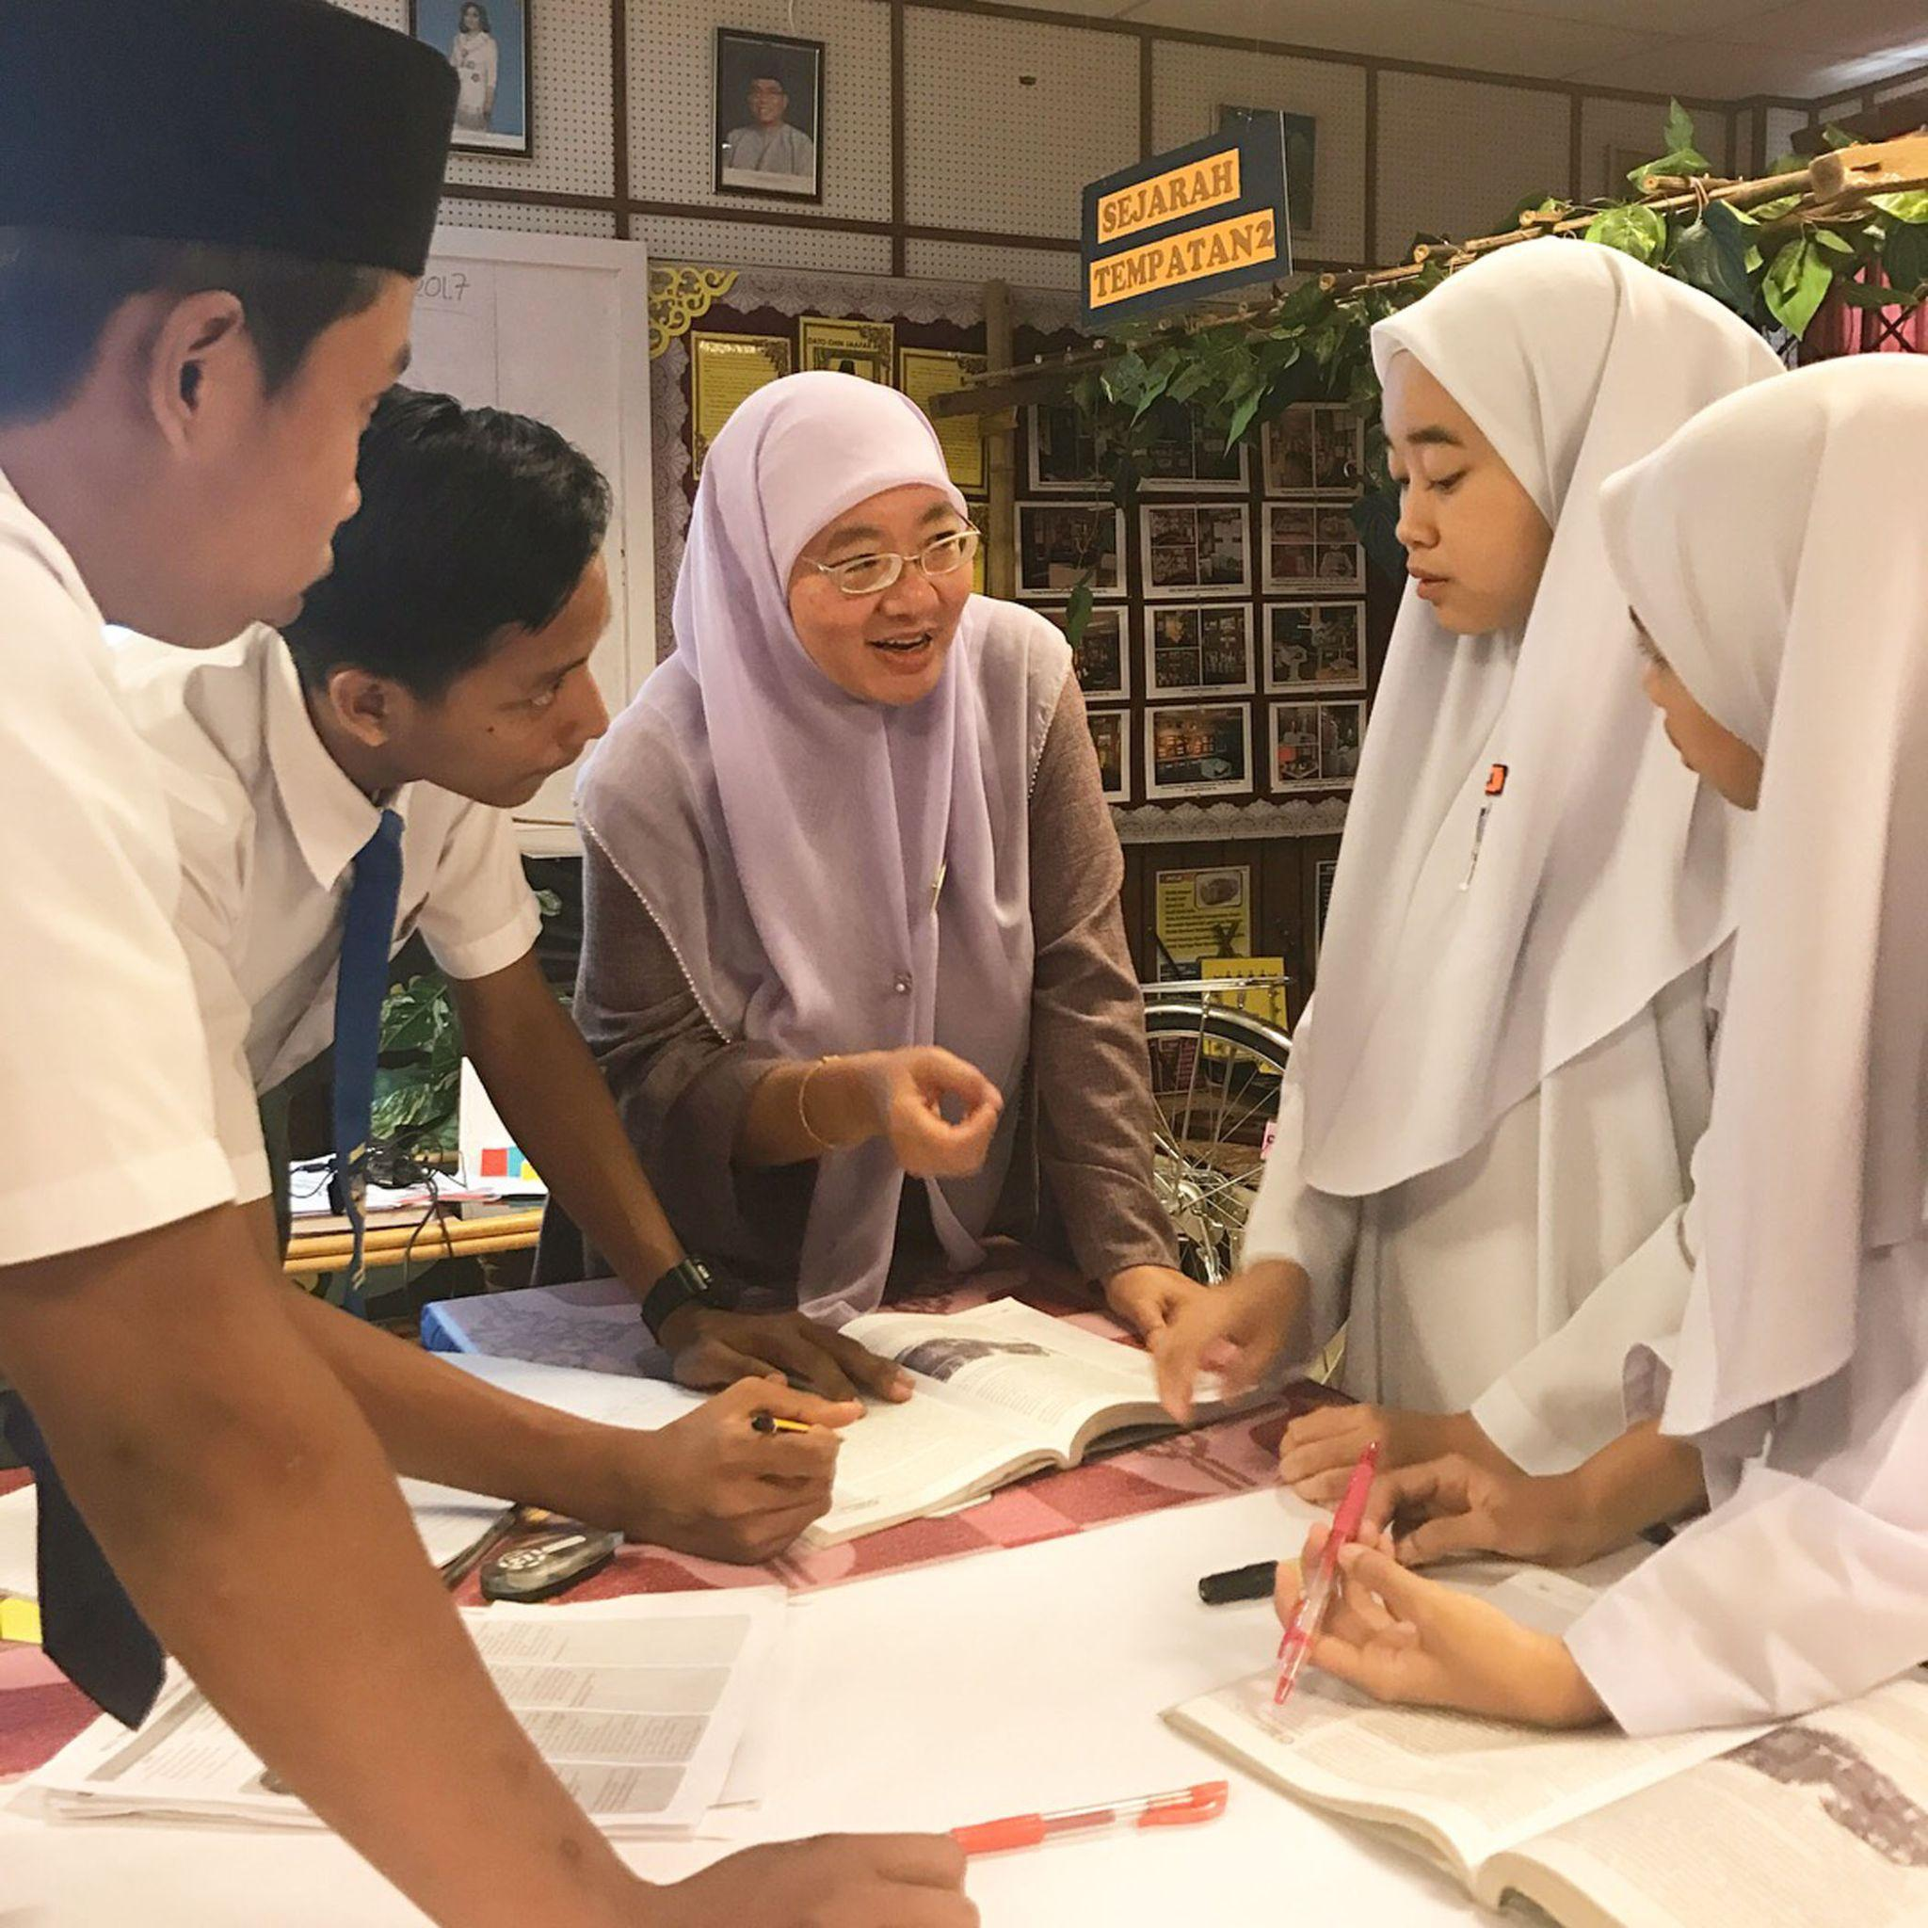
YBhg. Datuk Dr. Habibah Binti Abdul Rahim during TFM Week 2017

Note to editor:

About Teach For Malaysia
Teach For Malaysia is an independent, not-for-profit organisation, on a mission to give all children the opportunity to realise their potential through quality education. We partner with the Ministry of Education to reach high-need public schools. It is one of the 60 partners of the prestigious global education network, Teach For All.

Since 2012, Teach For Malaysia has been building a transformational movement in our education system by placing the country’s most promising leaders as full-time teachers in some of Malaysia’s most high-need schools to combat education inequity through our flagship programme called the Fellowship. In 2020, we expanded our work to also train and coach in-service public school STEM teachers through the 2-year Program Duta Guru (PDG).

Teach For Malaysia is a 2022 Merdeka Award Recipient under the Education & Community Category. The Merdeka Award is Malaysia's premier award for excellence founded by PETRONAS, ExxonMobil and Shell in 2007.

Since our launch in 2012, our movement of 474 Fellows, 583 PDG teachers and Alumni has impacted over 330,285 students in 893 schools across the country.

For more information, please contact:

Felicia Tan
Marketing Manager
Teach For Malaysia
Tel: +6017 3711 571
Email: felicia.tan@teachformalaysia.org
Website: www.teachformalaysia.org
Twitter: https://twitter.com/teachformsia
Facebook: https://www.facebook.com/teachformalaysia
Instagram: https://www.instagram.com/teachformsia/

- End of document -

